**Topology:**

In an integrated satellite-terrestrial communication system, the network topology consists of two main types of nodes: satellite nodes and ground nodes. These nodes play distinct roles in facilitating communication between different locations on Earth. Here's a more detailed elaboration on these node types:

1. Satellite Nodes: Satellite nodes are crucial components of the integrated communication system, orbiting the Earth in space. They act as relay stations that receive signals from ground nodes and then transmit these signals to other ground nodes, or satellite nodes. Satellites offer a wide coverage footprint and can span across vast geographical regions, making them suitable for long-range and global communication.

These satellite nodes are equipped with communication payloads, antennas, and other essential equipment that allow them to handle various types of signals, such as data, voice, and video. As they move in orbit, their positions change continuously. This movement is typically controlled and synchronized to ensure seamless communication handovers between satellites as they pass over different parts of the Earth. This constant motion allows satellites to cover different areas, avoiding coverage gaps and ensuring continuous connectivity.

1. Ground Nodes: Ground nodes, also referred to as terrestrial nodes, are the fixed communication points on the Earth's surface. These nodes can include various types of communication devices, such as cell towers, base stations, ground stations, and other infrastructure components. Ground nodes serve as the primary endpoints for communication with users and other ground-based systems.

Ground nodes are strategically placed across the terrestrial network to provide reliable and localized communication services. They establish connections with satellite nodes when required, and also enable direct communication with other nearby ground nodes. In the case of mobile communication, ground nodes may interact with moving user devices, such as smartphones or laptops, enabling seamless handovers as users move within the network's coverage area.

The integration of satellite and ground nodes creates a hybrid network that leverages the strengths of both systems. Satellite nodes provide long-range and global coverage, making them ideal for reaching remote or underserved regions, while ground nodes handle local communication with lower latency and higher data rates. By combining the two, the integrated communication system can achieve a robust and efficient network capable of supporting a wide range of applications, from rural connectivity to disaster recovery and beyond.

To model such a communication system effectively, it's essential to consider the dynamics of satellite movement, ground node distribution, signal handovers, and network protocols to ensure seamless communication between the two node types. We considered all these aspects in our simulation. Following is a snapshot of our initial topology:

**LEO Orbit:**

We modeled the orbit of satellites to be LEO orbit. LEO satellites are placed in orbits relatively close to the Earth's surface. This proximity to the Earth results in several distinctive characteristics that make LEO satellites suitable for integrated satellite-terrestrial communication:

**a) Short Orbital Period:** LEO satellites have a notably short orbital period, completing one full round trip around the Earth in approximately 128 minutes. This rapid orbital motion enables them to cover the Earth's surface more frequently compared to satellites in higher orbits, resulting in increased communication opportunities with ground nodes.

**b) Continuous Movement:** Unlike Geostationary Orbit (GEO) satellites, which appear stationary relative to the Earth's surface due to their synchronization with the planet's rotation, LEO satellites are in constant motion. This continuous movement ensures that LEO satellites cover different regions of the Earth at various times, providing global coverage with multiple satellites working together as part of a constellation.

Following is a comparison snapshot of our topology at different time steps:

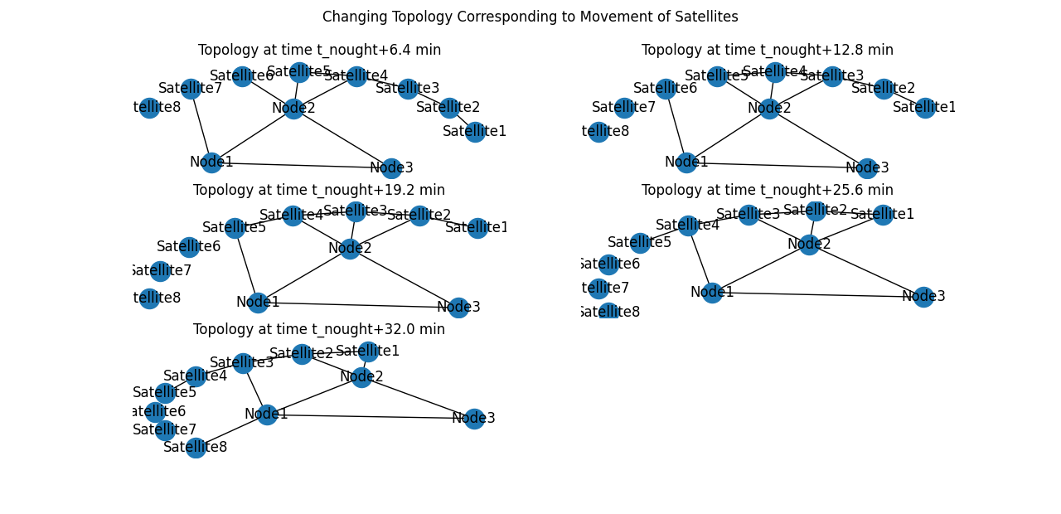

Topology snapshots here are taken at roughly 7 minute intervals.

**Link Capacities:**

In the integrated satellite-terrestrial communication system, link capacities play a critical role in determining the data transfer capabilities between different nodes within the network. Specifically, the link capacities vary depending on the type of communication channel established, whether it is between ground nodes or between ground nodes and satellite nodes. The link capacities are defined as 5 GB (gigabytes) for ground-to-ground nodes and 1 GB for ground-to-satellite nodes. This section will elaborate on the significance of these link capacities and their implications on the overall system performance.

**1. Ground-to-Ground Node Communication (5 GB):** The link capacity of 5 GB for ground-to-ground node communication refers to the maximum amount of data that can be transmitted between fixed terrestrial nodes within the network. This high capacity link is ideally suited for communication between stationary points on the Earth's surface, such as cellular towers, base stations, or other infrastructure components. The higher capacity facilitates the efficient exchange of data, voice, and multimedia content between geographically closer nodes.

The 5 GB link capacity ensures that terrestrial nodes in close proximity can enjoy fast and reliable communication, which is particularly beneficial for high-bandwidth applications, such as video streaming, large file transfers, and data-intensive processes. Moreover, this link capacity enhances the communication experience for users within the coverage area of ground nodes, supporting seamless real-time communication and other bandwidth-demanding services.

**2. Ground-to-Satellite Node Communication (1 GB):** Conversely, the link capacity of 1 GB for ground-to-satellite node communication is designed to accommodate the unique characteristics of satellite-based connections. Since satellite nodes are in constant motion, and their positions change in orbit, the link capacity is adjusted to suit the data transmission requirements of satellite communication.

The 1 GB link capacity for ground-to-satellite nodes reflects the need to efficiently manage the communication traffic between the Earth's surface and satellites in Low Earth Orbit (LEO). While this capacity is lower than the ground-to-ground link, it is still sufficient for various communication tasks, including telemetry data, command signals, and moderate data transfers. Satellite nodes act as relay stations, receiving signals from ground nodes and transmitting them to other ground nodes within their coverage areas. The 1 GB link capacity ensures that these satellite links can handle the communication needs effectively, despite the rapid movement and changing positions of the satellites.

1. **Optimizing Network Performance:** The distinct link capacities in the integrated communication system are carefully chosen to optimize the overall network performance. By providing higher link capacities for ground-to-ground communication, the system maximizes data throughput for terrestrial nodes that can handle large data volumes efficiently. On the other hand, the lower link capacity for ground-to-satellite communication aligns with the dynamic nature of satellite nodes, ensuring that data exchanges between ground and satellite nodes are effectively managed.

**Dynamic Link Formations due to Satellite Movements:**

In the our simulation, ground nodes maintain connections with satellites that are present in their vicinity at any given time. We call this connectivity strategy as dynamic satellite selection or proximity-based routing, which ensures that ground nodes establish links only with the most suitable satellites that can efficiently relay their communication signals. Here, we will elaborate on the significance and benefits of this approach.

**1. Proximity-Based Satellite Selection:** The dynamic satellite selection process is driven by the concept of proximity-based routing. When a ground node intends to establish a communication link, it evaluates the available satellites in its vicinity, focusing on those that are orbiting closest to its geographical location. By doing so, the ground node minimizes signal propagation delays and optimizes data transmission efficiency. This real-time evaluation and adaptation allow the communication system to adapt to changing conditions, as satellites are constantly moving in their orbits.

**2. Minimizing Signal Latency:** One of the primary advantages of connecting to nearby satellites is the significant reduction in signal latency. As the distance between the ground node and the selected satellite decreases, the time taken for signals to travel back and forth also decreases. Lower signal latency translates to improved responsiveness in communication, particularly for real-time applications like voice and video calls, where delays can adversely affect user experience.

**3. Seamless Handovers:** As the LEO satellites orbit the Earth at high speeds, ground nodes experience satellite handovers as they move through the coverage areas of different satellites. The proximity-based satellite selection ensures that handovers between satellites are managed efficiently. When a ground node moves out of the coverage area of one satellite and enters the coverage area of another, the communication link seamlessly switches to the new satellite with minimal interruption. This seamless handover capability enhances the reliability of the communication system, ensuring continuous connectivity for users on the move.

**4. Load Balancing and Congestion Management:** Another benefit of dynamic satellite selection based on proximity is the potential for load balancing and congestion management. By connecting to the closest available satellite, the system can distribute the communication load more evenly across the satellite constellation. This load balancing approach prevents individual satellites from being overloaded with traffic, thereby enhancing the overall network performance and stability.

**5. Robustness and Adaptability:** The use of proximity-based routing makes the communication system more robust and adaptable to changing conditions. Satellites may experience temporary signal obstructions or interference due to atmospheric conditions or other factors. By dynamically selecting satellites in the vicinity, the ground nodes can quickly switch to alternative satellites, maintaining the continuity of communication even in challenging scenarios.

**Details of VNE in our Simulation:**

In our simulation, ensuring efficient and optimal data routing is crucial to deliver reliable and high-performance communication services. To achieve this, a Virtual Network Embedding (VNE) algorithm is employed whenever topology connections change. The VNE algorithm reevaluates the current unfulfilled requests in the network and computes new optimal routes for data transmission based on the updated topology. This process ensures that data is routed through the most suitable paths, taking into account changes in satellite positions and network connectivity. It is vital to note here that whenever topology change occurs, VNE algorithm is re-run again to embed all the requests on our physical topology. We could also follow another approach where we only embed those requests again, whose paths were disturbed during topology change, and do not re-embed the undisturbed requests. We sticked to the former approach as the later will result in sub-optimal network usage.

**1. Dynamic Topology Changes:** The integrated communication system operates in a dynamic environment where satellite nodes continuously change their positions in orbit, ground nodes may relocate, and new nodes may join or leave the network. As a result, the network's topology is subject to frequent changes, potentially leading to variations in communication links and connectivity paths.

**2. Fulfilling Communication Requests:** Ground nodes in the communication system generate communication requests that may involve transmitting data to other ground nodes or receiving data from satellites. These requests are submitted to the network with specific requirements, such as quality of service (QoS) parameters, bandwidth, and latency constraints.

**3. Virtual Network Embedding (VNE) Algorithm:** The VNE algorithm is a computational technique used to allocate network resources, such as bandwidth and processing capacity, to fulfill the communication requests in the most efficient manner. When topology connections change, the VNE algorithm is triggered to reevaluate the unfulfilled communication requests in the current network state.

**4. Computation of Optimal Routes:** The VNE algorithm computes new optimal routes for data transmission based on the updated topology. It considers various factors, including the locations of ground nodes, the positions of satellites in orbit, link capacities, and QoS requirements of communication requests. By considering these factors, the algorithm aims to minimize signal latency, avoid congested links, and optimize resource utilization to meet the specific demands of each communication request.

**Coordinate System:**

In our integrated satellite-terrestrial communication simulation, we have chosen to use a **2D coordinate system** instead of **celestial coordinates** to model the positions and movements of satellites and ground nodes. The 2D coordinate system simplifies the simulation while still allowing us to capture essential aspects of the communication network.Top of Form

**Results**

Following are the graphs, with brief explanation, generated at the end of the simulation.

**Spectrum occupancy:**

**Bottom of Form**

This graph represents the percentage remaining capacity in network as the time progresses and the requests keep coming. For the following graph, we allowed maximum of 5 requests. As the time passed, more requests came, and thus the overall spectrum occupancy has decreasing trend.

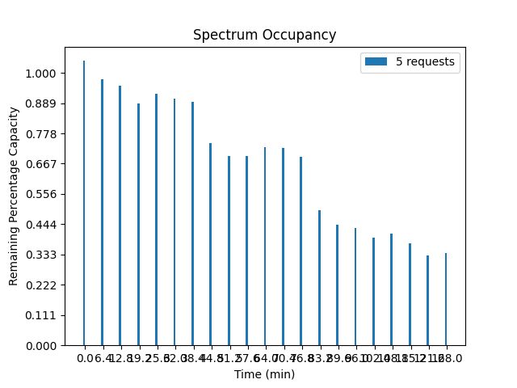

**Ground Spectrum occupancy:**

**Bottom of Form**

This graph represents the percentage remaining capacity of ground to ground nodes only as the time progresses. For the following graph, we again allowed maximum of 5 requests. As the time passed, more requests came, and thus the overall spectrum occupancy has decreasing trend.

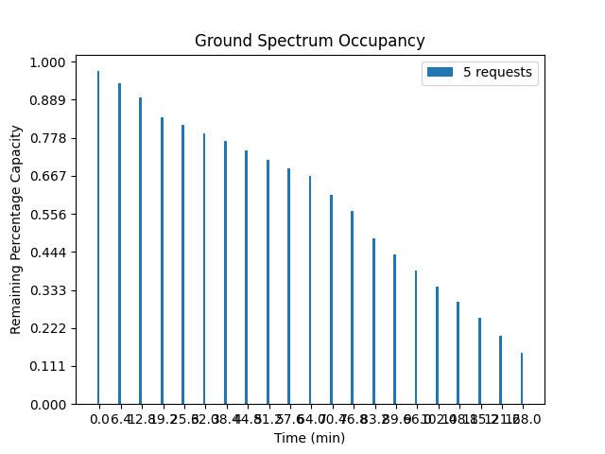

**Satellite Spectrum Occupancy:**

This graph represents the percentage remaining capacity of satellite to satellite nodes only as the time progresses. For the following graph, we again allowed maximum of 5 requests. As the time passed, more requests came, and thus the overall spectrum occupancy again has decreasing trend.

**Satellite to ground Spectrum Occupancy:**

This graph represents the percentage remaining capacity of satellite to ground nodes only as the time progresses. For the following graph, we again allowed maximum of 5 requests.

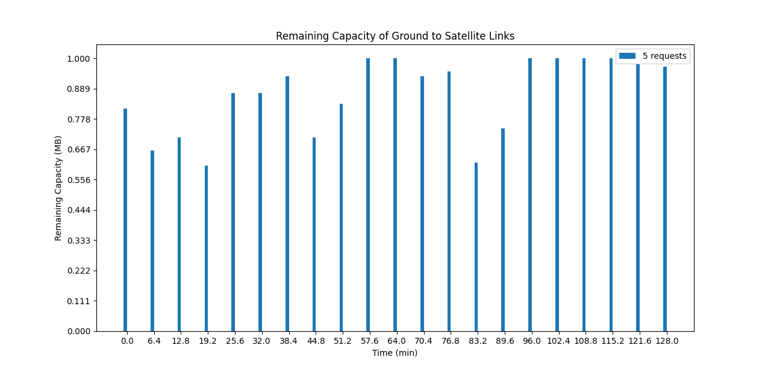

Following is a comparison of spectrum occupancies of all types of links at different time snapshots, with maximum of 5 allowed requests in our simulation.

